|  |  |  |
| --- | --- | --- |
| **Ex No-05** | **Use Autopsy to create a case and import evidence** | **Date-** |
| **Reg No-** |

# Aim:

**Description:**

Autopsy is an open-source digital forensics platform used for analyzing and extracting data from digital devices. Here's a step-by-step process on how to use Autopsy for a basic forensic investigation:

Drive link: <https://drive.google.com/drive/u/1/folders/1ilSFY7Tqn2L7AjQGhq8yJ8kixc_xTU-v> Download files: 4Dell Latitude CPi.E01, 4Dell Latitude CPi.E02

# Installation

* + **Download and Install**: Autopsy can be downloaded from the official website. Follow the installation instructions based on your operating system (Windows, Linux, or macOS).

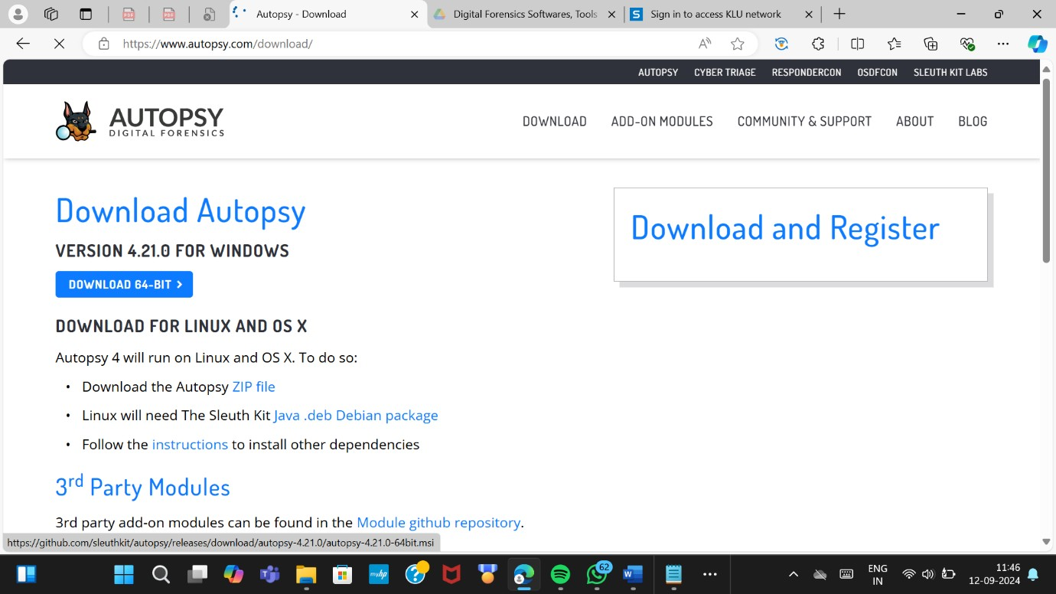

# Starting a New Case

* + **Open Autopsy**: Launch the application after installation.

# Create a New Case:

* + - Click on New Case.
    - Enter the case name and location where the case data will be stored.
    - 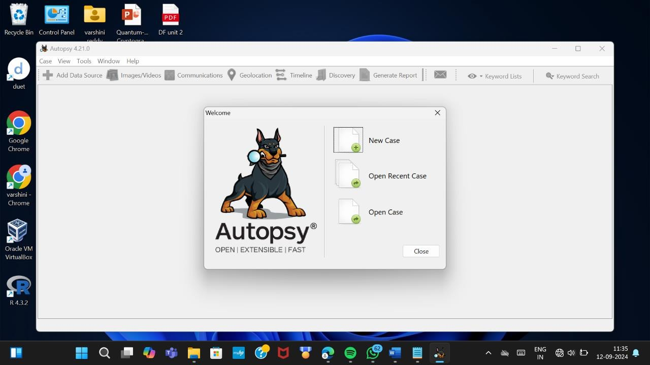Fill in the details like the case number, examiner's name, etc., and click Next.

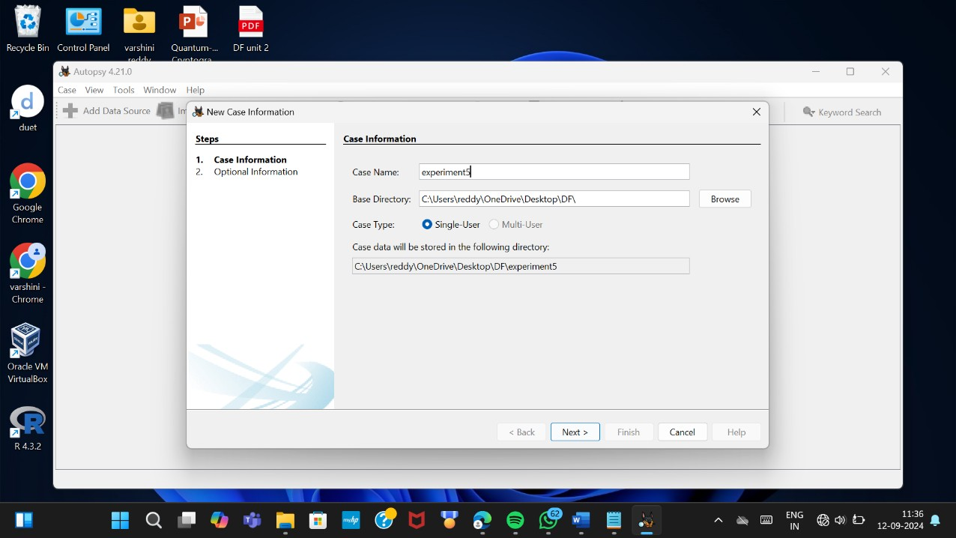

# Adding a Data Source

* + **Choose the Type of Data Source**:
    - After creating a case, you'll be prompted to add a data source.
    - You can add disk images, directories, logical files, or local disks.

# Select the Data Source:

* + - Browse to the location of the image file (e.g., .E01, .dd, or .raw), physical disk, or directory you want to analyze.
    - 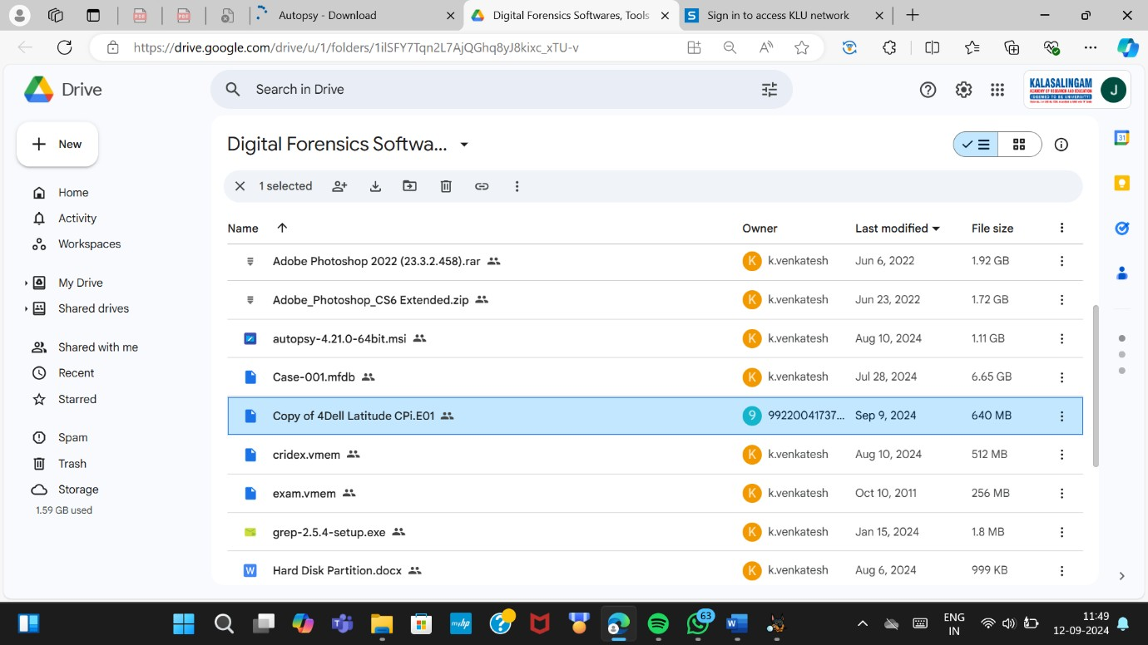<https://drive.google.com/drive/u/1/folders/1ilSFY7Tqn2L7AjQGhq8yJ8kixc_xTU-v>

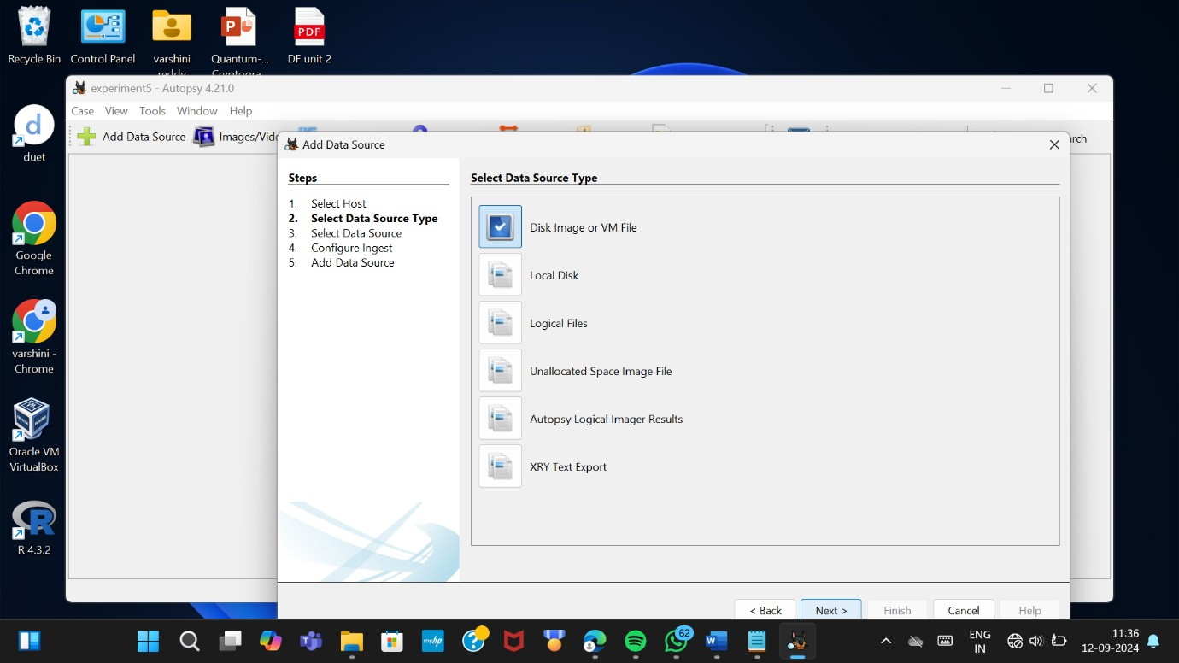

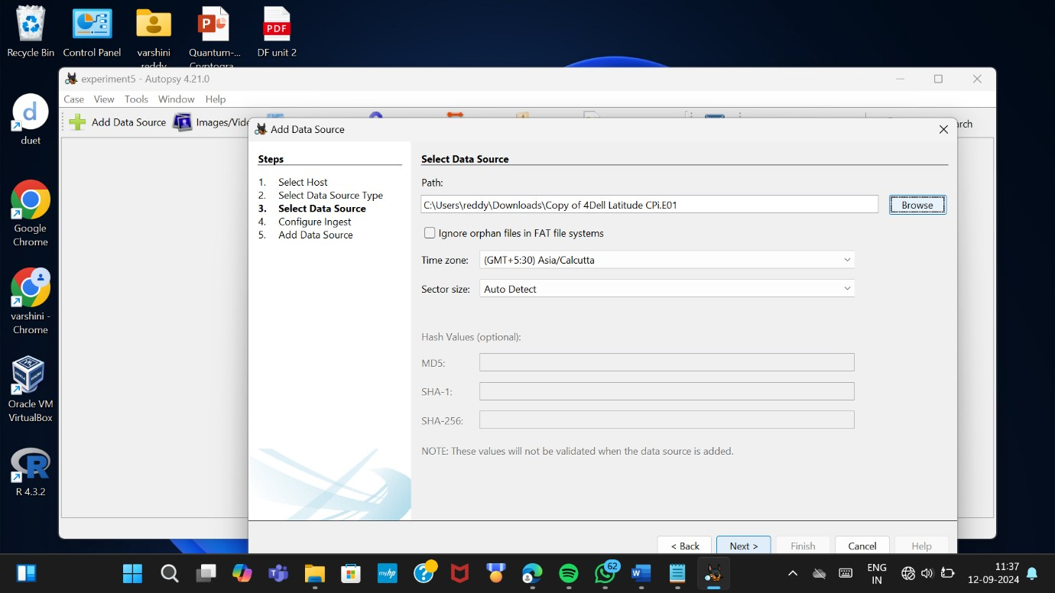

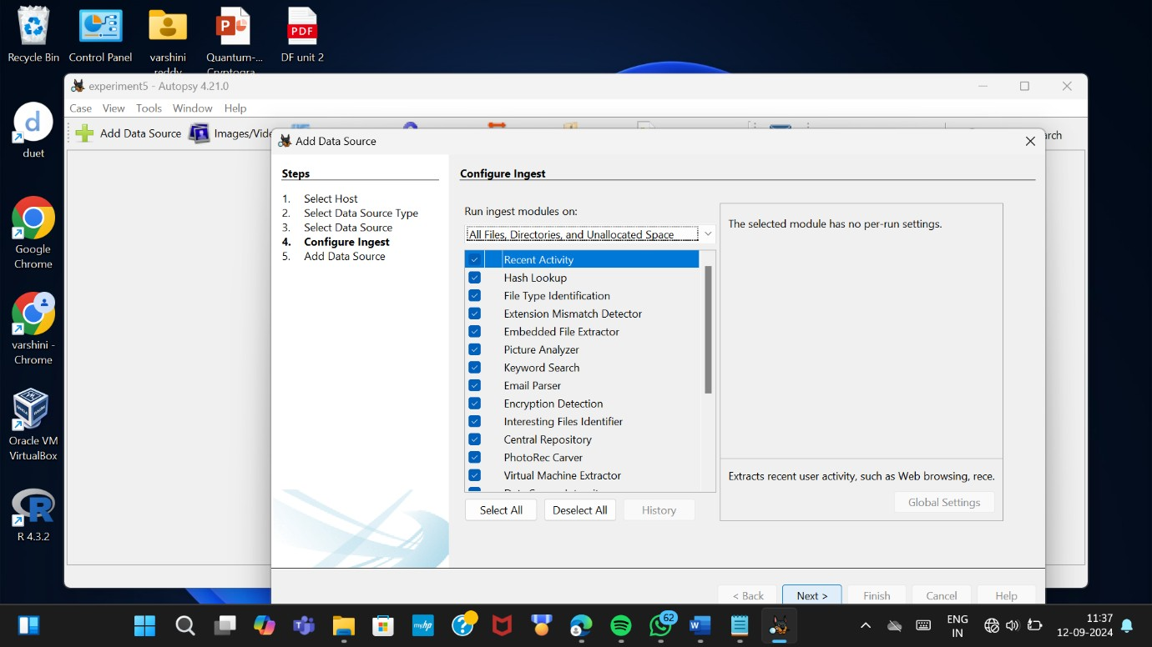

# Initial Analysis and Overview

* + **Ingest Progress**: As Autopsy processes the data source, you'll see the progress in the lower- left corner.

# Explore the Resulting Artifacts:

* + - Autopsy automatically categorizes findings such as web artifacts, file system metadata, and communication records.

# Use the Tree Viewer:

* + - On the left pane, you’ll see a tree structure where you can explore different aspects like File System, Web History, Email, etc.

# Detailed Analysis

* + **Keyword Search**:
    - You can perform specific keyword searches using the Keyword Search module.
    - Use pre-configured lists or enter custom keywords.

# File Analysis:

* + - Navigate through files and folders under the File Types or File System section.
    - Open, view, or export files for further examination.

# Timeline Analysis:

* + - Use the Timeline module to visualize events based on timestamps.
    - This can help track user activity over time.

# Hash Analysis:

* + - 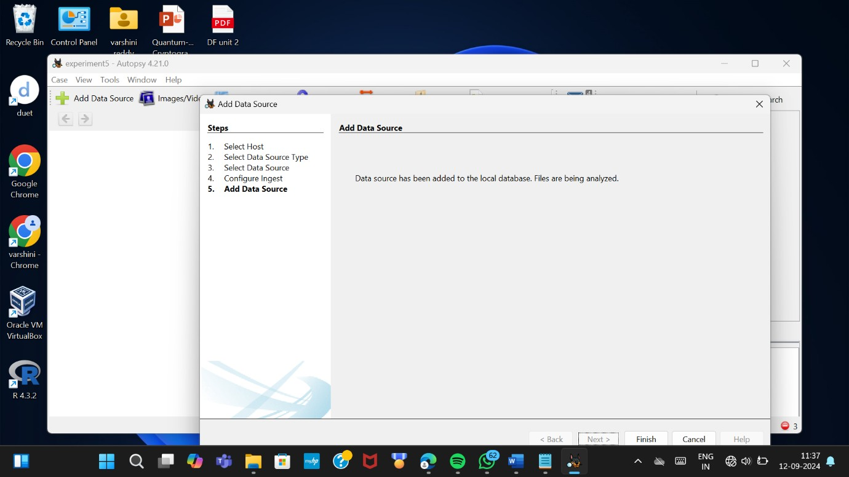Compare file hashes with known databases to identify known good or bad files.

# Reporting

* + **Generate a Report**:
    - After analyzing the data, click on Generate Report from the toolbar.
    - Choose the type of report (HTML, CSV, Excel, etc.).
    - Select which parts of the analysis you want to include in the report.

# Export Findings:

* + - Export individual files or artifacts that you need for your report or further analysis.

# Final Review:

* + - Review the report to ensure it includes all relevant information.
    - Save or print the report for use in your case.

# Case Closure

* + **Close the Case**:
    - Once you have completed your investigation, close the case within Autopsy.

# Archiving:

* + - Ensure all data and reports are properly archived according to your organization's policies.

# Advanced Features (Optional)

* + **Custom Ingest Modules**:
    - Autopsy allows for custom modules to be added if you need specific analysis tools not included by default.

# Collaboration:

* + - Autopsy can be configured for multi-user cases if you’re working in a team environment.

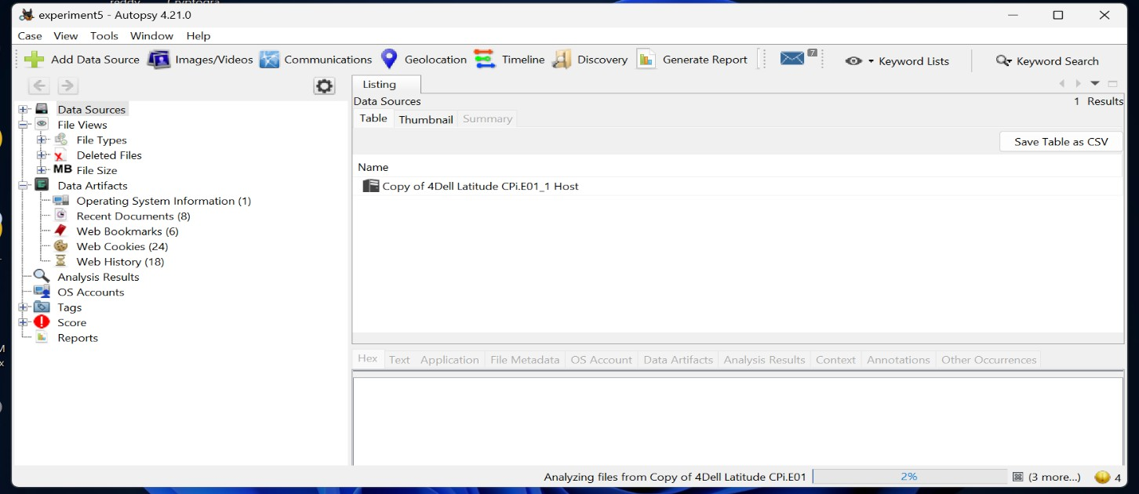

**Result:**